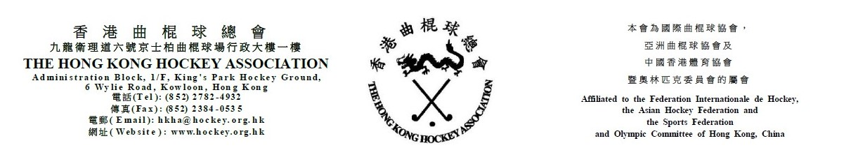

The Hong Kong Hockey Association
10th Annual General Meeting
Thursday, 20 July 2023
Attendance Form

(Please see notes below before completing the form)
The following is authorized to represent __________________________________ (Member Club) at the HKHA AGM on Thursday, 20 July 2023:-

Authorized to Vote
(tick one box only)
1. _____________________________________ ( )
(Name)
2. _____________________________________ (Reserve representative) ( )
(Name)
Note: Owing to the capacity constraints of the venue, one representative from each club is invited to attend the HKHA AGM. Clubs can nominate a reserve representative only in the event the original assigned representative cannot attend.

(Name of Club Official) |  | (Signature of Club Official)

(Position of Club Official) |  | (Date)

Notes: (1) Club officials include President, Chairman, Hon. Secretary, Convenor and Hockey Section Captain.
- This form must be received by the HKHA office no later than Thursday, 13 July 2023.

